**Assignment -I**

**1. Electron Devices**

Q.1 Determine ID, VD2, and Vo for the circuit.

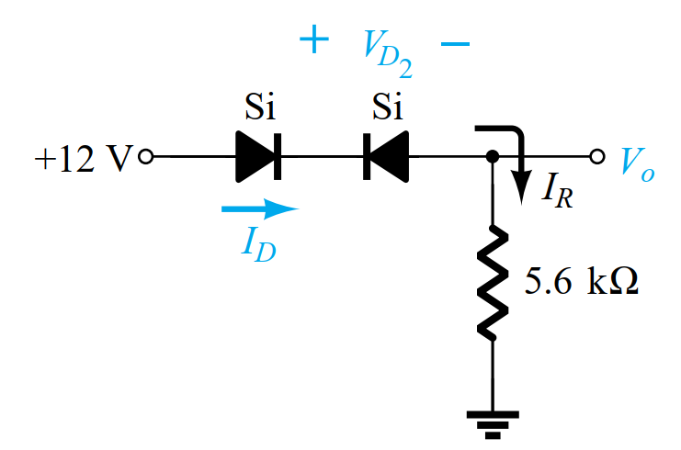

Q.2 Given the load line of Fig. and the defined Q-point, determine the required values of VCC, RC, and RB for a fixed-bias configuration.

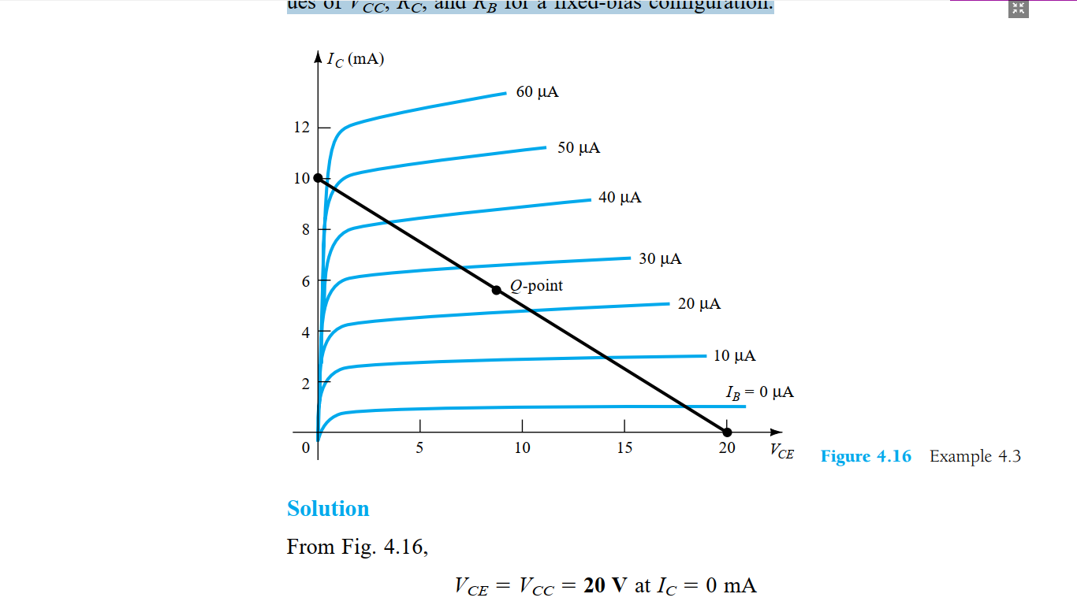

**2. Analog Electronics**

Q.1 When the gate to source voltage (VGS) of a MOSFET with threshold voltage of 400 mV, working in saturation is 900 mV, the drain current is observed to be 1 mA. Neglecting the channel width modulation effect and assuming that the MOSFET is operating at saturation, find the drain current for an applied VGS of 1400 mV.

Q2. A Colpitts oscillator has a coil with an inductance of 50 μH and is tuned by a capacitor 400 pF across amplifier input and 200 pF across the output. What is the frequency of oscillation and the minimum gain for maintaining oscillations?

Q3. Determine the lower cut-off frequency for the circuit given β = 100 and r0 = ∞Ω

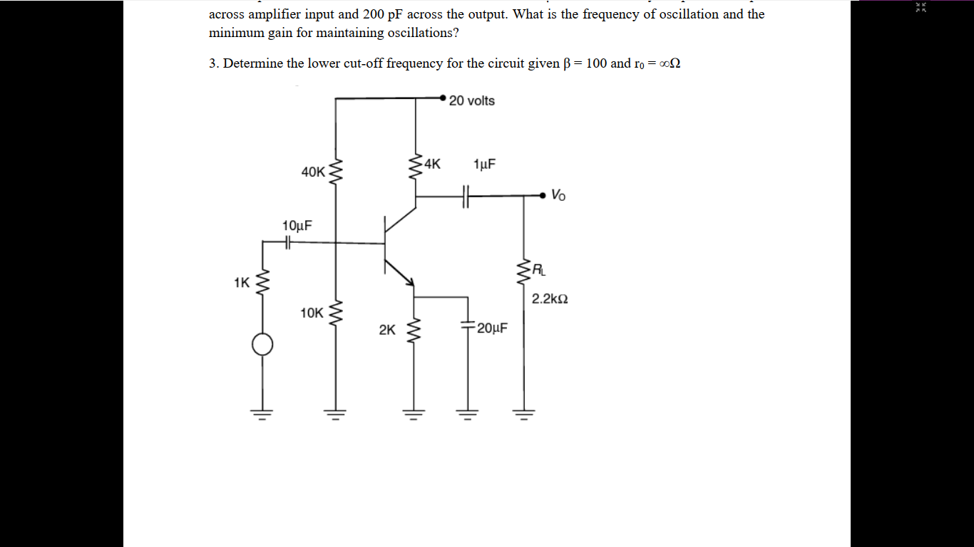

**3. Digital Electronics**

Q.1 Simplify the Boolean expression Y (A, B, C, D) = ∑m (0,1,2,4,6,7,10) using K-map and implement it using logic gates.

Q.2 Design the given logic gates using Diode-Resistor Logic (DRL): - **AND, OR**

**Instruction:**

1. Prepare separate thin Note for assignment.
2. Assignment submission last date 16-2-2023.
3. There is 20% marks for assignments.